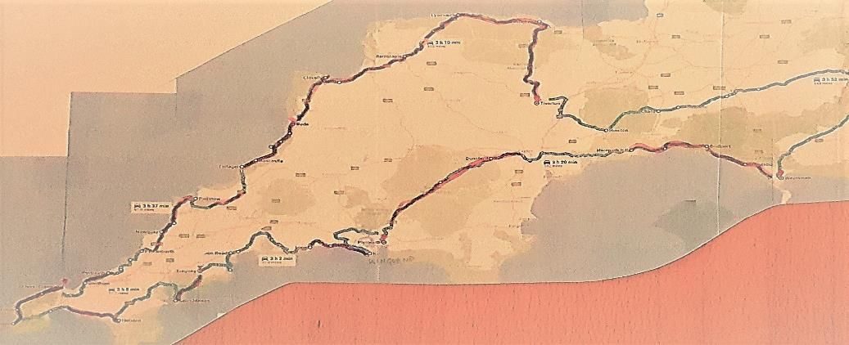
Epic drives –
Dorset + Devon + Cornwall
- by Tony Bovenkamp

Introduction
OK, so you’ve got yourself a lovely little Mazda MX-5, or some other form of fun transport, and now you would REALLY like to take it out for a ‘proper’ run.
Release all those horses from under the bonnet and experience what happens when they all pull together to haul you around some sharp corners, up a hill and down some steep descents …..
Now add to that the thrill of open-top driving, some clear skies and many breath-taking views along the way, and you will find that an ear-to-ear grin is as good as guaranteed.
Finding myself in that same position of wanting to take my lovely MX-5 Indiana on just such a drive, I did extensive research on the web during winter 2017/2018 to find out what others had posted about ‘best driving roads’, ‘scenic routes’ or even ‘epic drives’ in Dorset, Devon and Cornwall. I ended up with a map of south-west England full of highlighted roads that were of interest.
To make that into something usable I then set about creating a circular route that includes as many of those interesting roads as practical. This resulted in the route described below, which I am happy to share so that others may enjoy it also.
As we live on the Surrey/Hampshire border I made Weymouth our starting point and also our first overnight stop, allowing us to take in several interesting roads on the way there from our home.
The main route is split up in 6 stages of around 3 hours driving each, some more some less
Stage 1 takes in Devon’s picturesque south coast and most of Dartmoor National Park, which has lovely views like this :
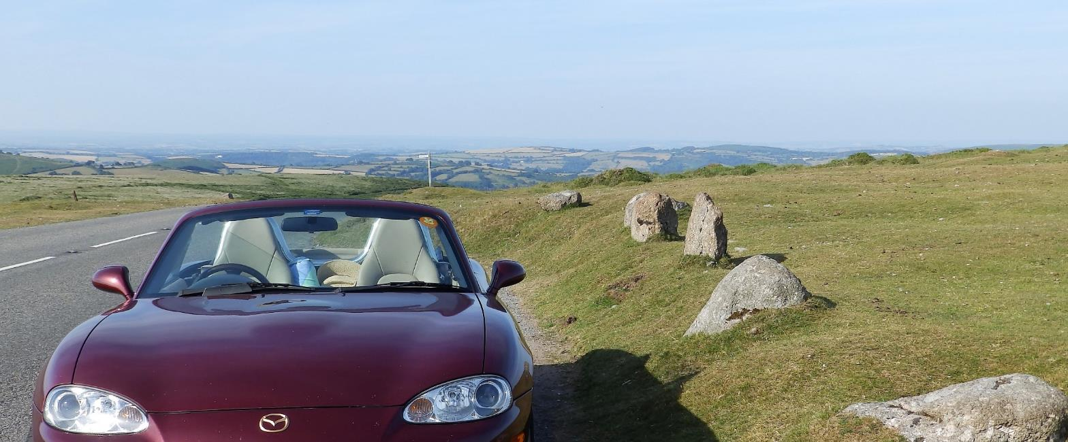

Stage 2 is all Cornwall south coast, taking in Whitsand Bay and passing places like Looe, No Man’s Land, and the breathtaking Polperro and Mevagissey. Not to forget Chesil beach (in the background) :
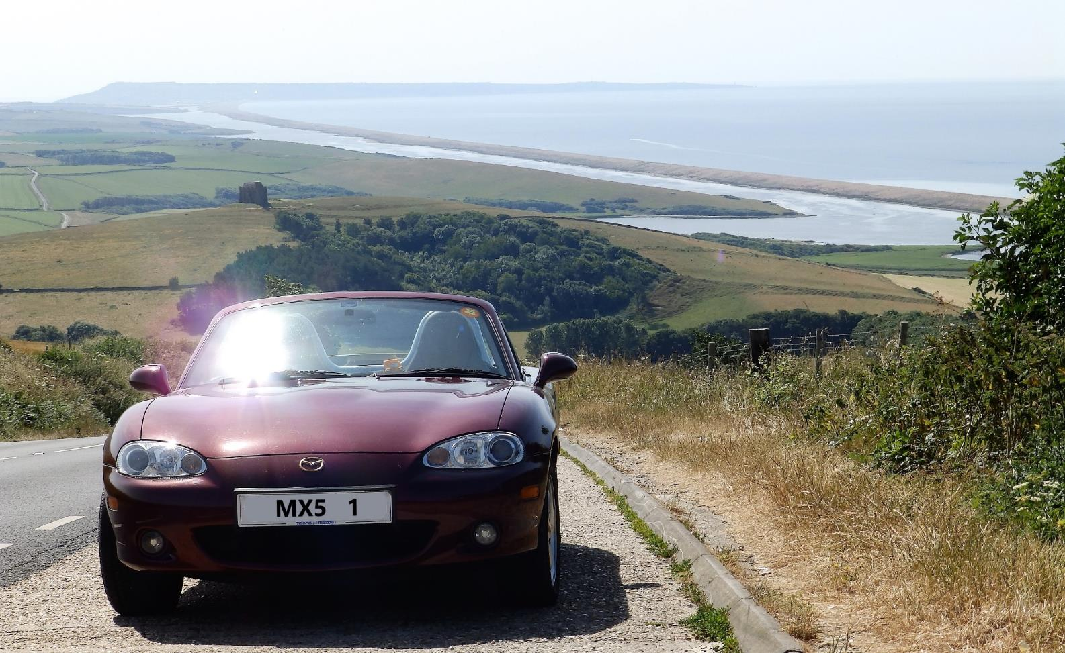

Stage 3 is the remainder of Cornwall’s south coast almost as far as Land’s End and then up Cornwall’s west coast to the idyllic St Ives.
It passes the tiny St Mawes castle :
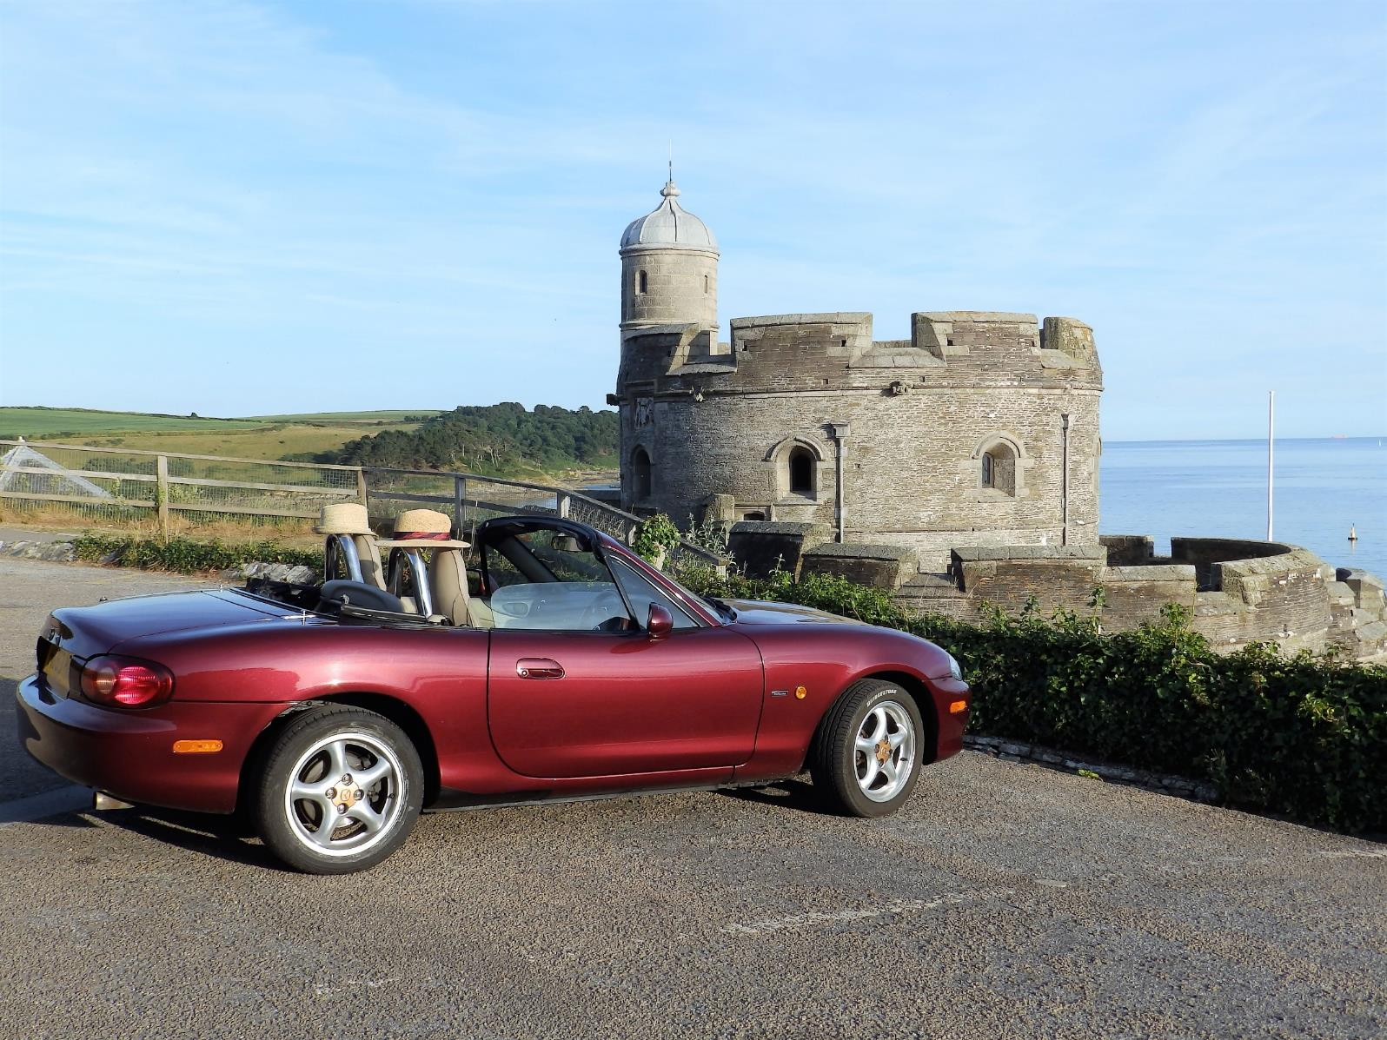

and takes in a ferry crossing of the river Fal :
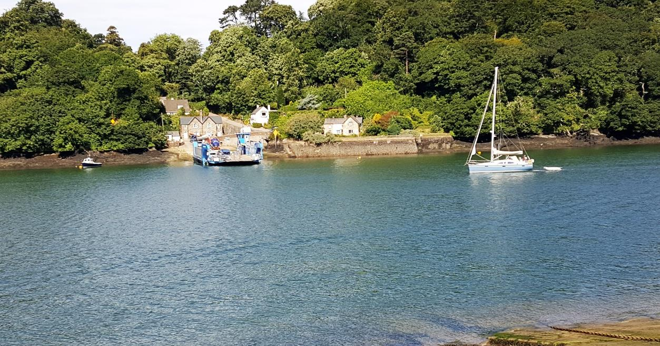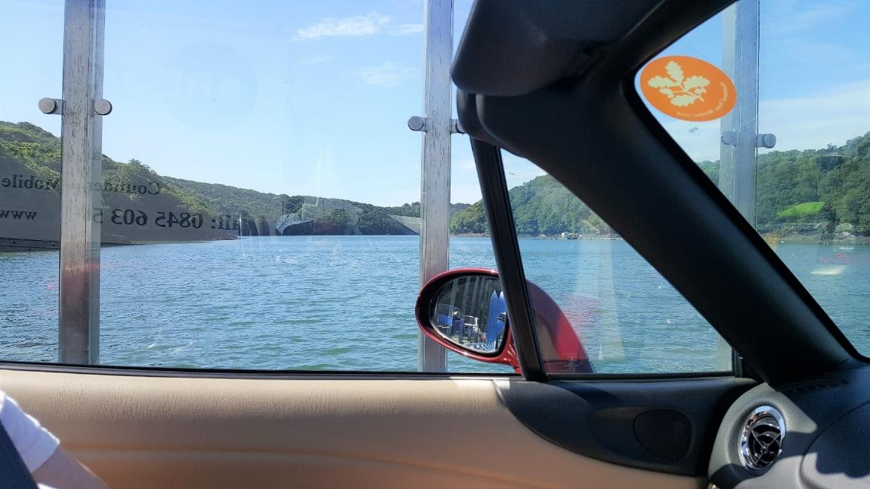

Stage 4 is all Cornwall west coast, taking in places like Portreath, Perranporth, Padstow, Tintagel and Boscastle, ending in Bude.
Fabulous views along the way here, particularly on the Tintagel – Bude stretch. This is the stretch near Perranporth:
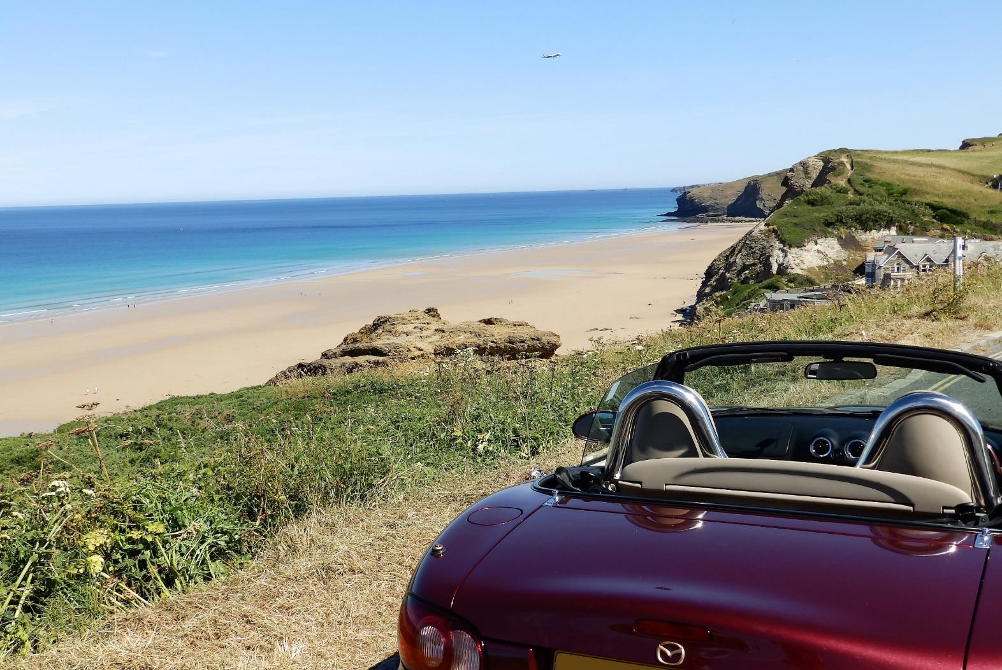

Before arriving in Bude there is a good challenge south of Widemouth near Millook Haven – if a 30% (yes 30!) descent didn’t quite do it for you, don’t worry there is also a 30% ascend soon after it, which
forced my little Indiana all the way down to first gear, which prompted my wife to say ‘I didn’t know it could do crawling as well !” .

This is the view shortly before Bude itself :
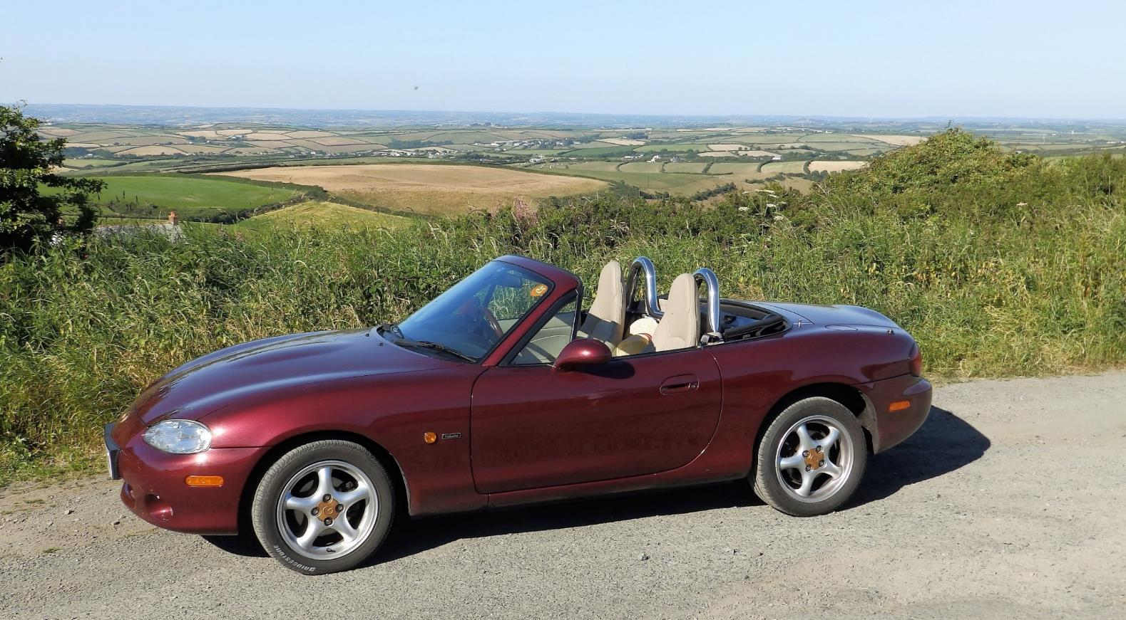

Stage 5 is all about the Atlantic Highway (A39) finishing the west coast of Cornwall, briefly touching Somerset’s northcoast and then heading back down into Devon. Barnstaple, Lymnouth, and my personal favourite stretch Dunster to Tiverton.

The final stage (stage 6) takes us back south to cross Devons’s south coast again, ending in Charminster which has some lovely B&Bs like this one :
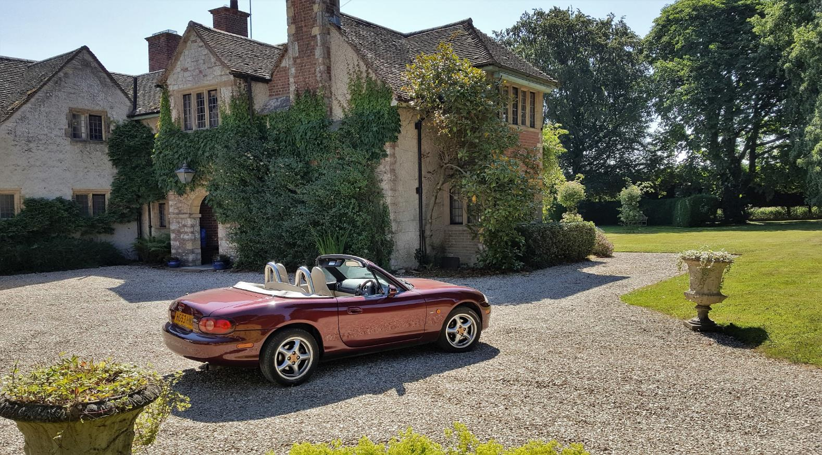

The end of stage 6 is very close to the start of Stage 1 (Weymouth) so combining all stages makes for a round trip. This then means that you can start and end your trip at any point along that route, wherever is most convenient to you. All directions assume a clockwise tour; counter clockwise is equally possible but you would have to reverse all directions yourself.
We did the whole trip at a leisurely pace of 1 stage per day, which leaves plenty of time for sightseeing, meals and other diversions along the way, including re-runs of particularly exciting stretches of road .
If you want to put more emphasis on driving then 2 stages per day (6 hours) is perfectly achievable and gets you around in 3 days. Bear in mind that this is intensive driving so do take a break from driving at regular intervals.
True ‘Pistonheads’ may even attempt 3 stages per day (up to 9 hours driving) which would make it possible to do the whole route over a single weekend. I feel this can only be done safely when there are at least 2 drivers per vehicle who share the driving equally.
Total distance (all the way round) is around 510 miles.
The route was built with Google Maps in January 2018. Bear in mind that roads may be congested or temporarily closed at any time, so it may not be possible or practical to follow the route exactly as described here. This is fine of course and may well lead you to discover an absolute gem of a diversion ! Embrace the adventure.
My favourite stretches ? Stage 3 Zennor to St Ives and Stage 5 Dunster to Tiverton – winding roads, lovely views with very, very few single track sections. Plus of course the 30% (!) descent and ascent near Millook Haven on the way to Widemouth (stage 4).
Finally - Enjoy, but at all times please drive safely and considerately. You will most likely come across tight situations like the one below, but with care and attention these never need to be a problem.

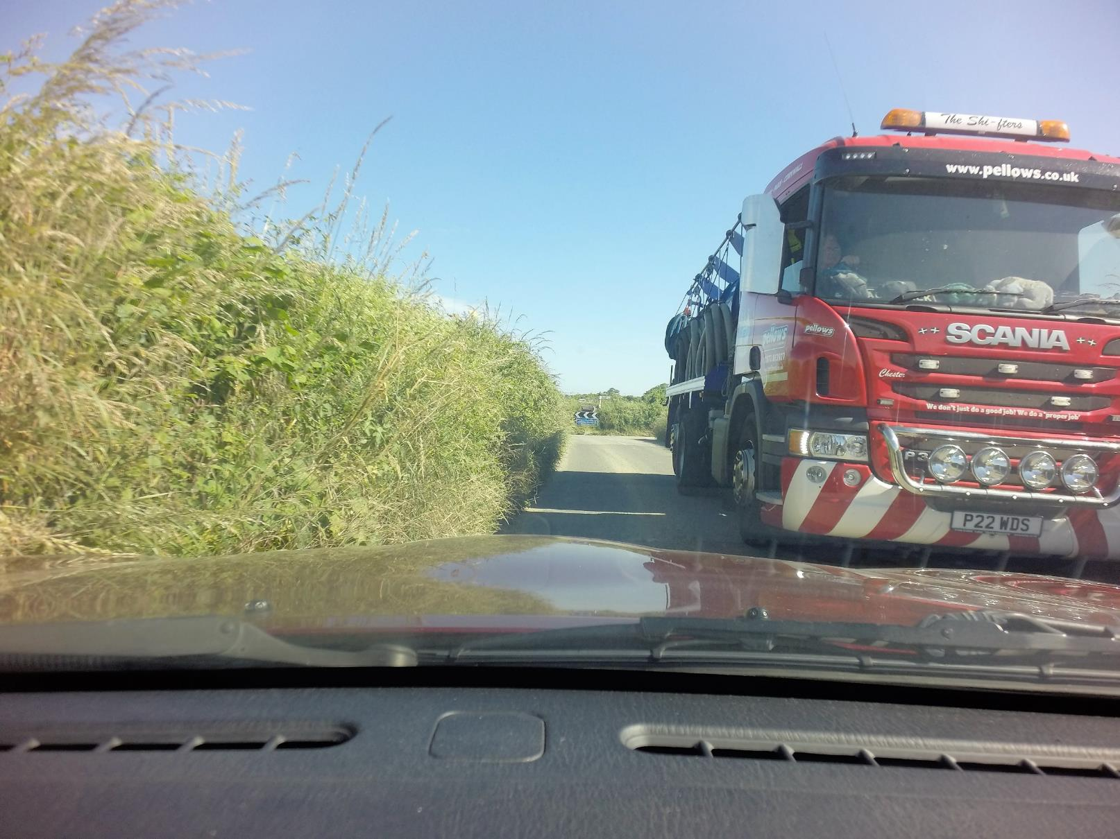
Contents
1 Stage 1 : Weymouth to Plymouth 3
1.1 Intro 3
1.2 Route Description 4
2 Stage 2 : Plymouth to Tregony 5
2.1 Intro 5
2.2 Route description 6
3 Stage 3 : Tregony to St Ives 7
3.1 Intro 7
3.2 Route description 9
4 Stage 4 : St Ives to Bude 10
4.1 Intro 10
4.2 Route description 12
5 Stage 5 : Bude to Tiverton 13
5.1 Intro 13
5.2 Route description 14
6 Stage 6 – Tiverton to Charminster 15
6.1 Intro 15
6.2 Route description 15

Stage 1 : Weymouth to Plymouth

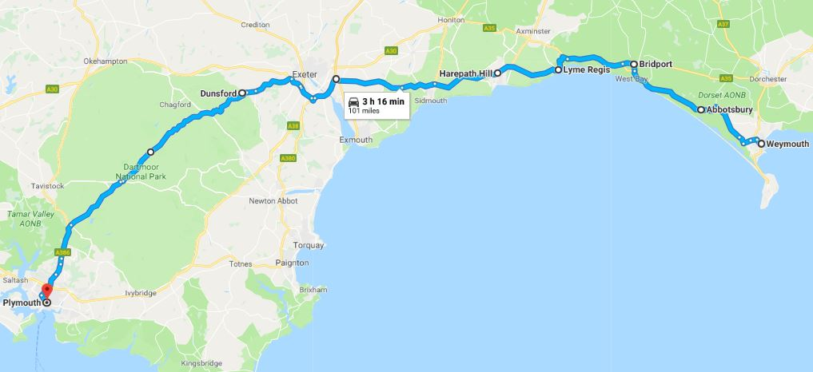

Intro

B3157 – Weymouth – Abbotsbury – Bridport
“The B3157 Jurassic Coast Road Drive is a full 18 miles of the best way to see the World Heritage Jurassic Coast .This is the route followed by the famous X53 Jurassic Coast bus from Poole to Exeter, and is the best bit of that route as far as coastal scenery is concerned.”
“For motorists and cyclists, this is almost certainly the best view of the Jurassic Coast to be had by road anywhere along its 96 mile length. But be warned, don’t let the scenery distract you from your driving!”
“The B3157 has beautiful views and is also an immensely enjoyable road to drive, but it also has twists and turns aplenty with blind bends and hidden dips.”
The sections in open country have a 50 mph limit for good reason and all the villages are 30 mph or less.
A3052 – Charmouth – Lyme Regis – Seaton – Sidmouth
“Charmouth is a friendly and traditional village situated at the heart of the UNESCO World Heritage Jurassic Coast, an ancient coastline of dramatic cliffs, fossils and beautiful scenery”
“The historic seaside town of Lyme Regis nestles in an Area of Outstanding Natural Beauty at the point where the rugged West Dorset and East Devon coastlines meet – the heart of the Jurassic Coast. The town and the surrounding area are renowned for their natural beauty, and it has a fascinating history stretching back to the 8th century.”
“Seaton sits on the Jurassic Coast and Dorset and East Devon Coast World Heritage Site. It offers natural wonders, family adventures, sporting opportunities and a large variety of places to eat, drink and relax. The famous South West Coast Path - one of the top walks to be found anywhere in the world- is easily accessible as well as the spectacular River Axe and Axe Valley wetlands.”
“Sidmouth is a Regency town on the Jurassic Coast. A town caught in a timeless charm. Beautiful gardens, leisurely walks, Regency history and architecture, fine hotels, clean beaches and friendly shops. It’s all here in this lovely seaside town that nestles beneath majestic red cliffs and green hills with its own micro climate.”

B3212 – Across the Moor. Exeter - Dunsford – Princetown - Yelverton
“At Exeter on the A30 you’ll be able to get across Dartmoor on the B3212. With excellent views of the moors throughout, it’s a road that zigzags across in some areas. If you’re in a car that handles well it’ll be a lovely drive. Smooth, sweeping, empty and some fantastic views. Great pubs and picnic spots along the entire route (watch out for the occasional sheep though)”
“Bovey Castle, past Moretonhampstead, offers spectacular views of the surrounding countryside. Lettaford is a village that you’ll pass that has been there in some form or another since 1300.”

Route Description

Length : approx. 101 miles, 3 hours 16 minutes; from Dorset via Devon into Cornwall
START – on the B3157 in Weymouth (near Charlestown) heading NORTH
Grid ref : 50°36'54.5"N 2°29'57.7"W
- Follow the B3157 to Abbotsbury and Bridport
- Just before Bridport join the A35 west to Chideock and Charmouth
- At Charmouth join the A3052 to Lyme Regis
- Continue on the A3052 to Colyford, Salcombe Regis, Sidford
- At Clyst St Mary join the M5 south towards Okehampton/Plymouth/Torquay for 3 miles
- At junction 31 exit the M5 onto the A30 towards Bodmin/Okehampton
- After 1.5 miles exit the A30 onto the A377 slip road towards Exeter/Credition
- After 0.2 miles turn left onto the B3212 to Dunsford, Moretonhampstead, Princetown, Yelverton
- In Yelverton take 1st exit (straight) on roundabout onto the A386 all the way to Plymouth [end of stage 1]

Stage 2 : Plymouth to Tregony

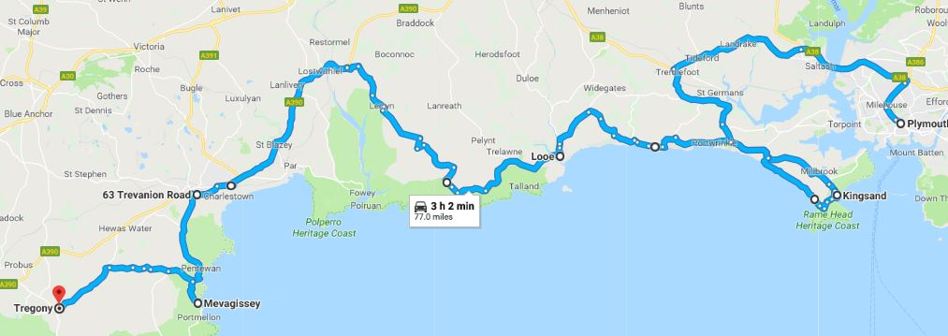

Intro

“For maximum impact start out on Rame Head and take the coastal road that sweeps above Whitsand Bay in a westerly direction so the coast on your left can be viewed in its full splendour. The road drifts high over the five miles of golden sand and rugged cliffs. As you float past beach huts perched on the cliffs you’ll pass through Freathy and onto Crafthole where the road continues into Looe.”
“Tucked away in South East Cornwall, Whitsand Bay is characterised by long stretches of golden sand which run from Rame Head to Portwrinkle, moving east to west. It’s considered to be one of Cornwall’s hidden gems. Whitsand Bay Beach has a constant swell, so if you wanted to take some time out from behind the wheel, it’s the perfect opportunity to take a dip in the surf. From the beach, you can move on through Freathy and Crafthole and you will eventually arrive in Looe. There’s lovely old charm to enjoy here, and Polperro is just a stone’s throw away. The Old Sail Loft Restaurant is one of Looe’s oldest buildings.”
“Looe is always a firm favourite with families - with its picturesque harbour, views of Looe island and the Rame peninsula and great family beach”
“In Polperro it is easy to step back in time in what is a largely an unspoilt fishing village. Its beautiful cottages cling to steep hillsides around a small harbour with spectacular views of land and sea making it an artist's paradise”
“Widely considered the most picturesque fishing village in Cornwall, little Polperro is a feast for the eyes. Experience a different kind of horsepower with a horse-drawn "bus" from the main car park to the village centre, and ride through the narrow alleys. Walk off your lunch on a classic coastal walk from Polperro to Lansallos (fewer than three miles/five kilometers away), exploring the cliff's edges by foot.”
“St. Austell is the most populous city in Cornwall and home to one big-time attraction: the global garden of the Eden Project (just off the A390 at St Blazey). The expansive property features a greenhouse complex the size of over 30 football fields”
“Narrow streets + steep valley sides lead down to the centre of the old Mevagissey where the distinctive twin harbour provides a safe haven for boats”
“Unveiled in 1992 from under decades of overgrowth, the Lost Gardens of Heligan were restored on a shoestring budget and hailed by The Times as “…the garden restoration of the century”. Today the mysterious gardens and estate offer over 200 acres for exploration.” “Explore the hidden jungle and walk across Cornwall’s very own Burma rope bridge!”

Route description

Length : approx. 77 miles, 3 hours . All in Cornwall.
START - Plymouth centre, on the roundabout where Saltash Rd(A386)/Cobourg St and Western Approach (A374) meet, heading to the A386
Grid ref : 50°22'31.8"N 4°08'33.6"W

- Take the A386, A38, A374, B3247 to Kingsand OR – take the ferry from Plymouth to Torpoint which brings you to Kingsand directly
- In Kingsand follow the road round via Fore St, Garrett St, Forder Lane, Rame Lane, Trehill Lane, Military Rd, back to the B3247 (through Freathy)
- Continue on the B3247 (left) to Crafthole and Seaton
- In Seaton turn left onto Looe Hill
- After 0.9 miles turn right onto Bucklawren Rd to No Man’s Land
- At No Man’s Land turn left onto the B3253 to St Martin and Looe
- Near Looe join the A387
- Stay on A387 to Barcelona (!), Polperro
- In Polperro, the A387 turns into Langreek Rd
- Continue on Langreek Rd to Lerryn and Bridgend/Lostwithiel
- In Bridgend join the A390 (left) to St Austell
- In St Austell turn left onto Pentewan Rd/B3273 to Mevagissey
- In Mevagissey turn back onto the B3273, then turn left to Lost Gardens of Heligan (you’ve just found them ! )
- Continue west on the same road until it joins the B3287 to Tregony [end of stage 2]

Stage 3 : Tregony to St Ives

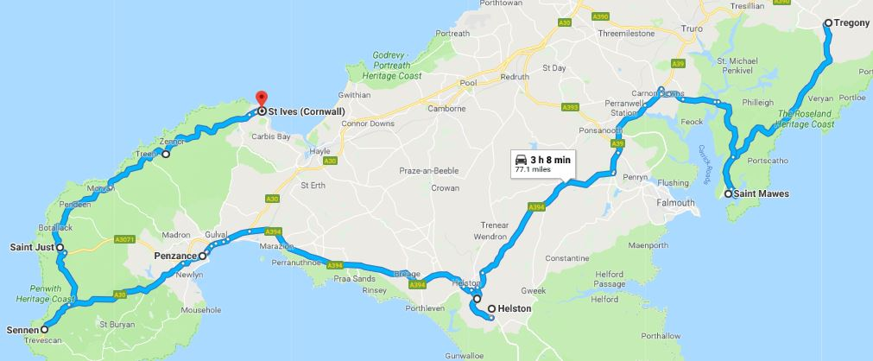

Intro

“The Roseland Peninsula offers another great Cornish driving experience. Exciting and winding rural lanes give way to glimpses of incredible scenery. You will have a mini adventure exploring the network of yet smaller lanes leading to hidden coves and picture perfect villages by veering off the A3078. You’ll find authentic Cornish villages with tales of smuggling like Portloe and wonderful beaches at Pendower. Leave the Roseland Peninsula by crossing the River Fal on the iconic King Harry Ferry next to the National Trust’s Trelissick garden.“
“Head to The Roseland peninsula for the ultimate Cornish driving experience for here single lanes are the norm and scenic views come courtesy of some exciting manoeuvring. “
“The Roseland Peninsula has some of the best countryside in the county. Refined and elegant, yet flowing and fast enough to excite, the peninsula and the Roseland Heritage Coast are among the most affluent areas of Cornwall. Trees predominate, and although largely wooded, the B3289 is a must drive.”
The pretty village of St. Mawes looks out over the River Fal towards Falmouth. The old fishing port boasts steep and narrow streets rising from the harbour.
“Helston is the geographic gateway to the Lizard Peninsula, with its small sandy coves, picturesque villages and some of the best pasties in Cornwall. The south tip is called Lizard Point and is the most southerly place in Britain”
“Some four miles from Penzance the idyllic St. Michael's Mount will come into view, which, through history, has been a tin-trading post, pilgrimage site, and military fortress. At low tide, you can walk right out to St. Michael's Mount via a causeway; when the water is up, opt for a short ferry ride from Marazion.”
“Just past Sennen is Land's End, the most westerly point of mainland England. One of Cornwall's most popular outdoor attractions, Land's End is chock full of museums and gift shops, but the natural beauty here wins out.”
“For an interesting 12 mile detour from Land’s End, head east on the B3315 for 6 miles to admire the Merry Maidens Circle. The best preserved late Neolithic site in the U.K., Merry Maidens Circle (‘Boscawen Un’) consists of 19 granite stones that form a perfect circle nearly 78 feet (23 meters) in diameter. “

B3306 Sennen – St Just – Zennor – St Ives :
“The B3306, also known as the West Cornwall Coast Road, is often voted one of the greatest driving roads in the United Kingdom for its scenery, with most of the road having views both across the Bristol Channel to the north, and the Cornish Moorland to the south. It hugs the coastline for a great proportion of its length.”
“Of all of Cornwall’s most scenic road trip routes, this was probably our favourite because of the incredible, sweeping views across the cliffs. The road hugs the coastline along the entire route. The dramatic cliff top landscapes, Cornish tin mines, famous lighthouses and rugged outcrops make this scenic drive one you won’t want to rush!”
“This stretch of road enjoys magnificent sweeping views across the west Cornish coast and beyond. The road quite literally hugs the remote coastline and falls away across fields which rest on mighty cliffs. With every twist and turn, the view gets even more glorious than before”
“If the road is busy with traffic it can get rather tiresome due to the lack of suitable overtaking opportunities. It’s worth pulling over and enjoying the stunning views over the sea until the road clears. If you’re lucky enough to find a quiet time you can cruise along totally absorbed in the S-bends strung together by a collection of short straights. In the right car at the right time this road can make you feel as if you’re soaring with the birds.”
“St. Ives is a multiple winner of the Britain in Bloom contest and a famed artist colony. Gaze out from St. Ives's harbour at Godrevy Lighthouse, made famous by novelist Virginia Woolf.”

Route description

Length : approx. 77 miles, 3 hours 10 minutes. All in Cornwall.
START – in the centre of Tregony heading south on the A3078
Grid ref : 50°15'57.1"N 4°55'05.7"W

- Follow the A3078 south to St Just in Roseland
- In St Just in Roseland either stay on the A3078 for a detour into Saint Mawes ….. or turn right onto the B3289 to Philleigh – Trelisick
- Take the Philleigh – Trelisick ferry (the ‘King Harry’ ferry) (small fee payable)
- In Carnon Downs join the A39 south towards Helston
- Near Falmouth university/Treliever roundabout take 3rd exit (right) onto the A394 towards Helston
- In Helston stay on the A394 all the way to Penzance
- In Penzance follow signs for the A30 Sennen
- (detour to Land’s End and/or Merry Maiden’s Circle?)
- In Sennen turn back onto the A30 and after 2 miles turn left onto the B3306 to St Just (& Land’s End airport)
- Just before St Just turn right onto the A3071/B3318
- After 1.5 miles turn left onto North Rd/B3318 (Pendeen) via Trewellard
- In Trewellard turn right onto St Ives road/B3306 to Pendeen
- Stay on the B3306 past Zennor and on to St Ives. [end of stage 3]

Stage 4 : St Ives to Bude

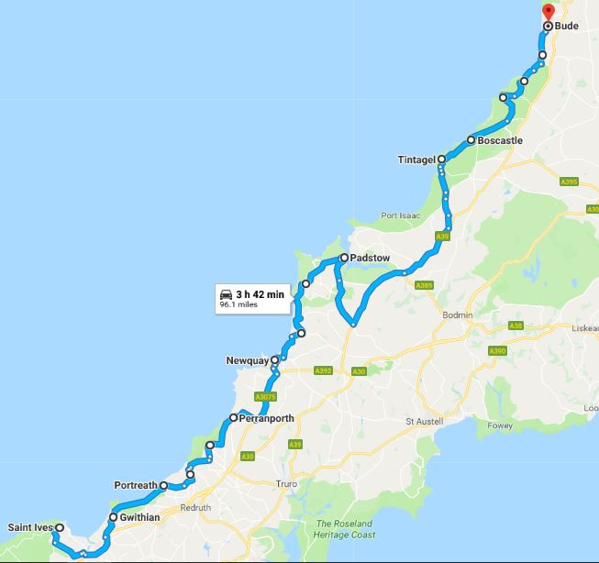

Intro

“Trevaunance Cove is the main beach at St Agnes and a family best kept secret. Lovely old harbour and a labyrinth of caves to explore”
“The scenic drive from Perranporth to Padstow is great for petrol heads, thanks to its hairpin bends and narrow coastal road. If you’re looking for a day on the beach, you’ll be spoilt for choice because most offer sweeping wide sands and the best surfing spots in the UK.”
“B3276 Newquay to Padstow - the road is sweeping, long, winding and infinitely enjoyable”
“Take the scenic route along the breathtakingly beautiful coastal roads which connect Newquay and Padstow. As Newquay disappears into your rear-view mirror you will sweep through Porth, Watergate Bay and Mawgan Porth with their surf washed golden beaches and hairpin bends before picking up the narrow coastal roads destined for Padstow. Detour from the B3276 and you will discover the infamous Seven Bays nearby; Porthcothan, Treyarnon, Constantine, Booby’s, Mother Ivey’s and Harlyn and Trevone.”
“Although a scenic route indeed, this drive is also about the incredible places to visit along the way. If you’re a fan of the British TV programme Doc Martin, a morning spent in Port Isaac is essential. A beautiful coastal path leads down to the village and here you’ll be able to see Doc Martin’s house as well as a few other filming locations. If you’re not a fan, the village is delightful. From here it’s a short but scenic drive to the most fantastic place in Cornwall, King Arthur’s Castle at Tintagel. We’re not usually big fans of popular tourist spots but this place is simply wonderful. Tintagel is where history meets legend and the views are payback enough for the initial climb to the cliff top. There is a steep climb up the uneven staircases to the top of the Tintagel cliffs. If you’re too tired to walk back up to the village when you’re done, you can take a ride in the Land Rover for a small fee.”
“Boscastle is a wonderful natural harbour in an otherwise inaccessible part of Cornwall. The hairpin bends leading down to the village are thrilling! Don’t leave Boscastle without indulging in the finest Cornish ice-cream on the planet because it’s hand churned, creamy and divine!”
“The Boscastle to Bude road is near the top of Cornwall’s most scenic road trip routes. Avoid the A39 and keep to the coast road to discover dramatic seascapes and curving clifftop roads.”
Boscastle to Bude
“Pick up the small coastal road from Boscastle and head north along the B3263 towards Bude and you will find yourself drifting along one of Cornwall’s most scenic stretches of coast. Your car will follow the curves of the dramatic coast and fly over the highest cliffs in Cornwall which stand at 223m above sea level. The road offers detours through Crackington Haven and 1 mile further along turn left at Tremayna Methodist Church towards Coxford and Widemouth Bay where magnificent sea views come into sight. The pounding surf and golden sands accompany the road through to Bude and star stuck drivers will find lots of handy lay-bys en-route offering tempting pit stops from which to soak in the view.”
“Bude is triple winner in the British Travel Awards for Best UK Coastal Town/Resort. Famous for its pastel painted beach huts, crazy golf + wide sandy beaches”

Route description

Length : approx. 96 miles, 3 hours 45 minutes. All in Cornwall.
START - near St Ives on the Hayle bypass/A30 heading towards Loggans
Grid ref : 50°10'28.2"N 5°25'19.1"W
- At Loggans Moore take the 1st exit (left) onto Carwin Rise/B3301
- At the next roundabout take the 2nd exit to stay on Carwin Rise/B3301
- Stay on the B3301 through Gwithian and Portreath
- In Portreath the B3301 turns right and becomes Penberthy Rd/B3300
- After 1.8 miles turn left onto Chapel Hill/Cambrose [direction St Agnes]
- After 1.9 miles (Porthtowan) continue onto Rose Hill [direction St Agnes]
- After 0.2 miles continue onto Coast Rd [direction St Agnes]
- After 2 miles turn left towards Penwinnick Rd/B3277
- In St Agnes keep right onto the B3285 ; stay on the B3285 to Perranporth
- Stay on the B3285 through Perranporth
- At Goonhavern take the first exit (left) onto the A3075
- Stay on the A3075 to Newquay
- Just before Newquay take 1st exit (left) onto Trevemper Rd/A392 towards Newquay
- After 0.5 mile take 2nd exit (right) onto Trevemper Road/A3058
- Stay on the A3058 through Newquay
- On the 2nd roundabout on Henver Rd take 1st exit (left) onto Porth Way/B3276
- Stay on the B3276 to Padstow
- Just before Padstow the B3276 turns right and becomes the A389
- Stay on the A389 past Padstow and keep left where the A389 becomes the A39
- Stay on the A39 until near Treburgett – turn left to St Teath
- In St Teath follow the B3267 north to Westdowns
- In Westdowns slight right onto the B3314 then slight left heading for Tintagel/B3263
- In Tintagel head north on the B3263 to Boscastle
- Stay on the B3263 through Boscastle, to Tresparrett Posts, Crackington, Crackington Haven, Dizzard (not via A39) and onto Marine Drive in Bude
[end of stage 4]

Stage 5 : Bude to Tiverton

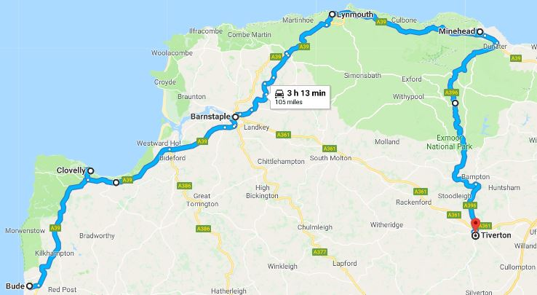

Intro

A39 Atlantic Highway
“Any road with the name ‘Atlantic Highway’ would make most car nuts sit up and pay attention, and the A39 is no exception. Historically a busy and dangerous road, especially during the summer months, the road is far more enjoyable during spring – when the flora is at its best and the small villages and countryside around it can be enjoyed. It has a bit of everything this road – and can be one of Cornwall’s most enjoyable in the sun.”
“Near Bideford the A39 crosses a big bridge over the River Torridge estuary which is really spectacular.”
“From Barnstaple it’s chicanes, hair pins and steep hills.”
“Countisbury Hill offers a lovely view of Lynmouth Beach”
Lynton and Lynmouth were known by the Victorians as Little Switzerland. Lynton’s town hall is very grand and 600 feet below Lynton is the small harbour of Lynmouth. The two villages are linked by a famous and ingenious cliff railway . Two rivers - the East Lyn and the Hoaroak - combine just inland from the harbour at Watersmeet and sweep down a spectacular gorge and through the village to the sea.
“Lynmouth to Minehead is a fantastic drive with scenery that will take your breath away, starting at the bottom of Countisbury hill in Lynmouth and taking in Porlock Hill (1 in 6 gradient !) near Minehead through heather country side and along cliff edges. Not for the nervous type, the roads are wide for country roads, gently winding along with occasional tight corners.”
“Fantastic drive, car needs to be sound due to steepness of hills, plenty of pull-ins en-route to take photos and have a cup of tea.”

Route description

Length : approx. 105 miles, 3 hours 10 minutes. Devon with a hint of Cornwall and Somerset
START – near Bude on the A39 heading north
Grid ref : 50°49'41.6"N 4°31'14.5"W

From Bude :
- Stay on the A39 -
to Clovelly (30 min, 17 miles),
to Barnstaple (33 min, 20.4 miles),
to Lynmouth (41 min, 19 miles),
to Minehead (32 min, 17.1 miles),
- At Dunster exit from the A39 onto the A396 to Tiverton
- Remain on the A396 all the way to Tiverton (55 min, 29.8 miles)
[end of stage 5]

Stage 6 – Tiverton to Charminster

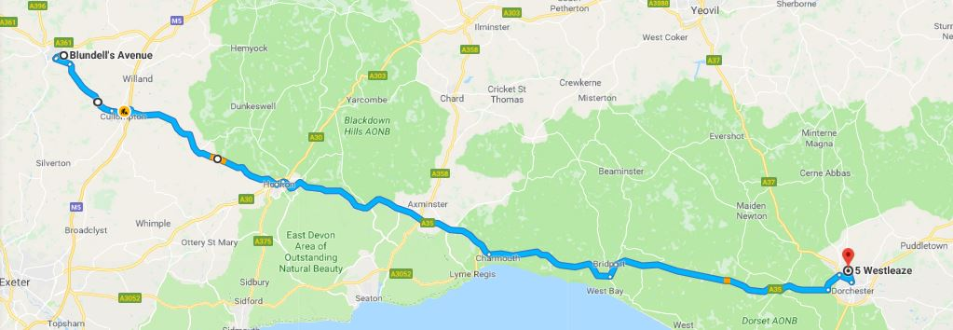

Intro

This is an easy stage, about half the distance and time of the others. The end of this stage has some overlap with the beginning of stage 1, although we are now driving in the opposite direction. It takes in several areas of outstanding natural beauty (AONB) and takes us back to close to the start of stage 1, which completes the circle.

Route description

Length : approx. 55 miles, 1 hours 30 minutes, from Devon to Dorset
START : In Tiverton on Canal Hill heading south-east towards Cullompton
Grid ref : 50°54'07.7"N 3°28'45.8"W

Stay on Canal Hill, Newte’s Hill and Little Toms to Cullompton
In Cullompton follow signs for the B3181 and A373 Honiton (don’t join M5)
In Honiton turn left onto High St and then follow the A35 to Wilmington, Kilmington, Charmouth, Bridport, Dorchester and Charminster [end of stage 6]

T H E E N D

